**Data Dictionary:** 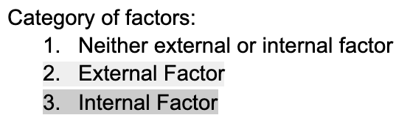

|  |  |
| --- | --- |
| **Attribute** | **Description** |
| CustomerID | Unique ID assigned to a customer upon registration. |
| Surname | Surname of customer |
| Tenure | Number of years the customer has been with the company |
| Exit-ed | Status of Customer  0 = Customer retained and is still a user of Bank’s services.  1 = Customer churned and has stopped using Bank’s services |
| CreditScore | Credit score of customer |
| Geography | Geographical location of the customer |
| Gender | Gender of customer: Male or Female |
| Age | Age of customer |
| Balance | Balance in the customer’s investment account |
| NumOfProducts | Number of investments made by a customer |
| EstimatedSalary | Estimated Annual Salary of the customer |
| FinancialLiteracy | Financial literacy of the customer  0 = novice  1 = intermediate  2 = expert |
| PersonalAdvisor | Customer is in contact with a financial advisor  0 = False  1 = True |
| NumberOfComplaints | Number of Complaints made by a customer |
| AverageOfCustomerFeedbackOnService | Average of the customer’s ratings on the service provided, ratings range: 0 (Worst) - 10 (Best) |
| UnresolvedComplaint | Customer has unresolved complaints  0 = False  1 = True |
| LastContactByABanker | Number of days after customer was last contacted by a banker |
| TimeBetweenRegistrationAndFirstInvestment | Number of days between registration and first investment for a customer |
| FrequencyOfContact | Number of times a customer was contacted by the customer service team in a year. |
| IsActiveMember | Amount of usage of benefits from Bank’s membership card  0 = Usage of < 80% of benefits  1 = Usage of ≥ 80% of benefits |